The Allen Chapel Riverside A.M.E. Church
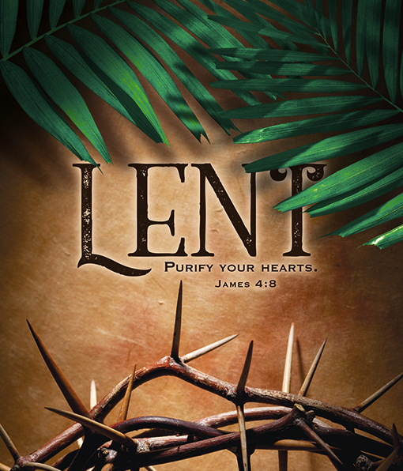

Order of Service

Praise & Worship …………………………………………...……...
Corporate Prayer …………………..……………………………….
Scripture Reading …………..………………………………………
Pastor’s Words/Pastoral Prayer …………………….….……..
Ministry of Music Selection ……………………..………….……
Proclamation by Pastor Barry Settle ……………………...….
Tithes & Offerings ………………….……………..…………………
Announcements ………………………………………………………..
Benediction …………………………………………………………...…

Announcements
