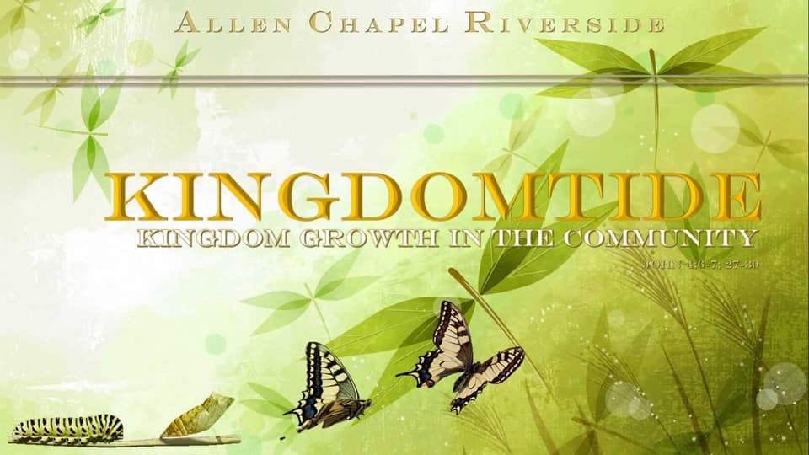

The Allen Chapel Riverside A.M.E. Church

Watch Us Sundays on Facebook Live @Allen Chapel Riverside
Livestream: https://allenchapelriverside.com

YouTube: Allen Chapel Riverside

Follow us on Facebook, Instagram, & YouTube!

Order of Service

Praise & Worship …………………………………
Opening Hymn …………………………………..
Invocation ……………...……..…………………….
Scripture Reading ……………. Luke 24: 13-35
Ministry of Music Selection ……………….……
Pastor’s Words/Pastoral Prayer …..………….
Ministry of Music Selection ……………….……
Proclamation by Pastor Barry Settle ……..….
Invitation to Salvation/Discipleship .…....……

Tithes & Offerings ……..……………...…………
Announcements ……......…………………………
\Benediction ……………..……………………...…

Announcements
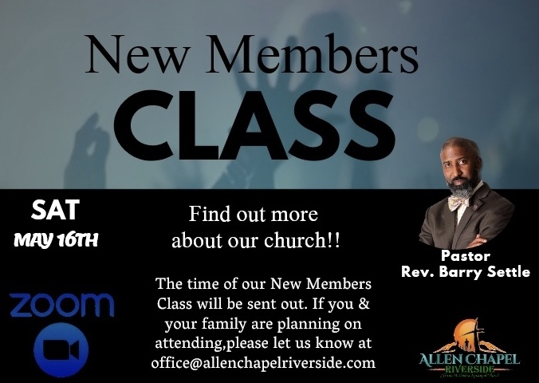

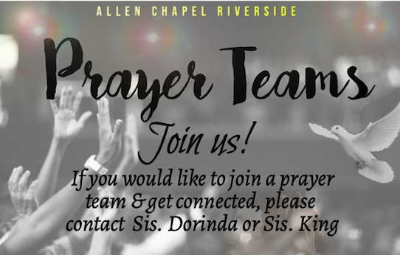

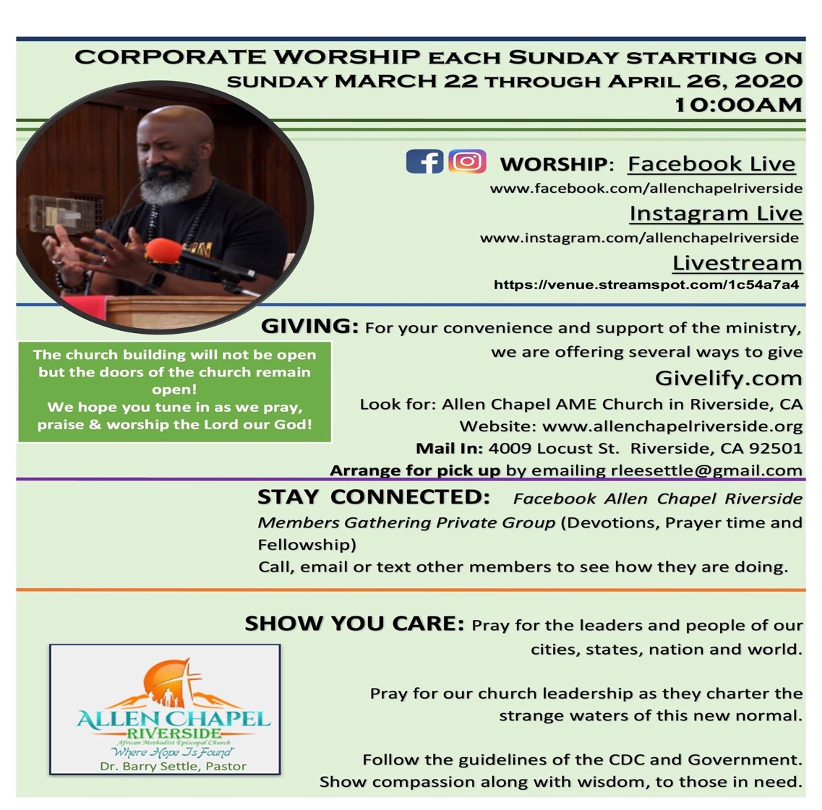

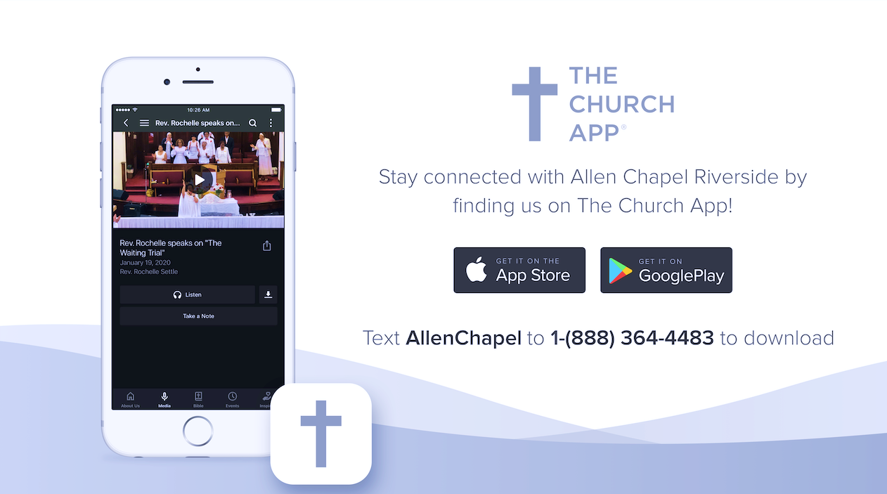

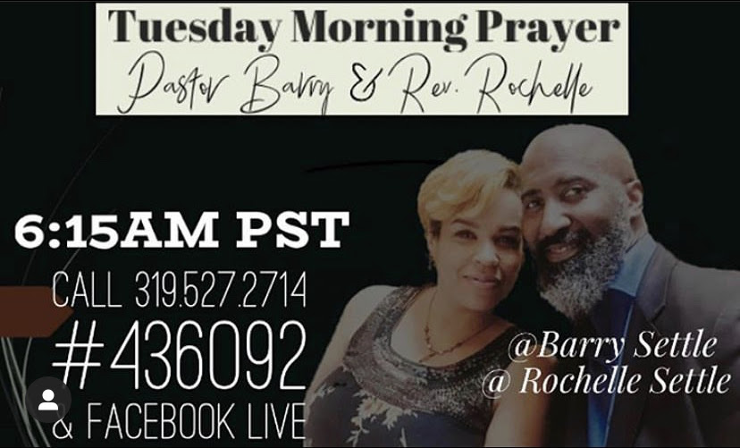

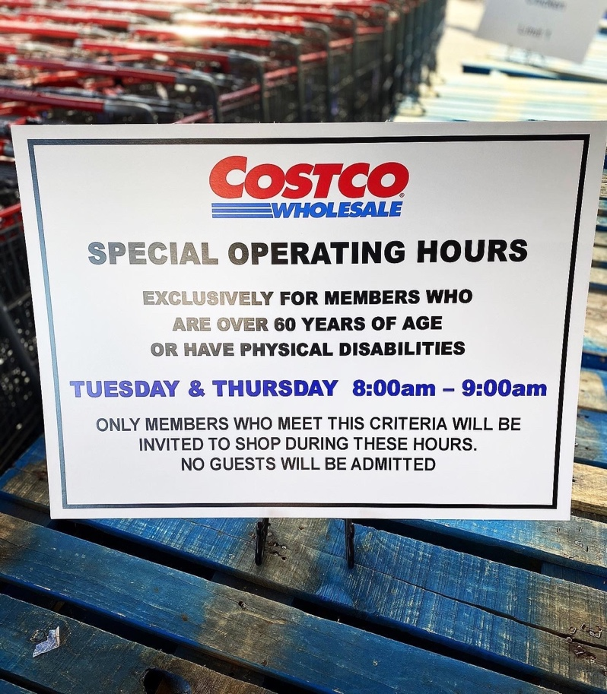
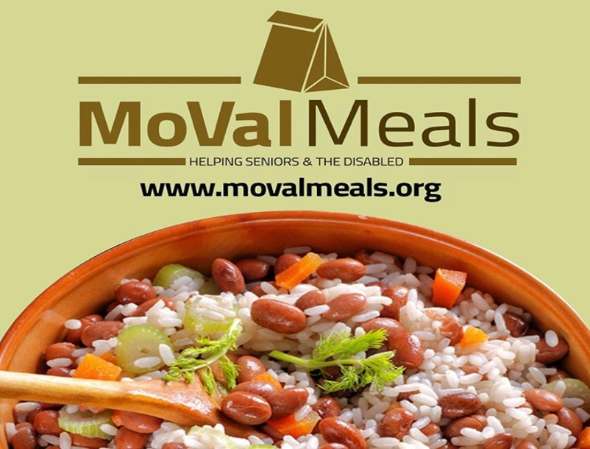

MoVal Meals! For Seniors age 60+ and Disabled Persons in Moreno Valley available for drive-thru pick-up at Moreno Valley’s Conference & Recreation Center
Monday-Friday 10am-2pm the day registering
Deliveries Tuesdays & Thursdays from 9a-4:30pm

Must register by phone at (951)413-3749 or email MoValMeals@MoVal.org

Social Action Commission Announcements

PLEASE COMPLETE YOUR CENSUS!!!!!!!
Your Census was mailed at the beginning of March. If you have not received your Census call 1-844-330-2020.

